**INTERNSHIP/TRAINING REPORT**

**“Store Management System”**

report submitted to the IIMT College of Engineering, Greater Noida in partial

fulfillment of the requirements for the award of the Degree of

**B.Tech**

**In**

**(Information Technology)**

**By**

*Richa Gupta 1902160130039 4th year*

Full time

Under the guidance of

Vandana Jha

(Duration: 27th June 2022 to 10th August 2022)



IIMT COLLEGE OF ENGINEERING, GR. NOIDA

(Department of Information Technology)

*(SESSION:2022-23)*



CERTIFICATE

This is to certify that **Richa Gupta 1902160130039** has carried out the mini project entitled as **“Store Management System”** during his intership, 7th semester under the supervision of  **Vandana Jha** in partial fulfillment of the requirements for the award of Bachelor of Technology degree in the department of Information Technology, IIMT College of Engineering.

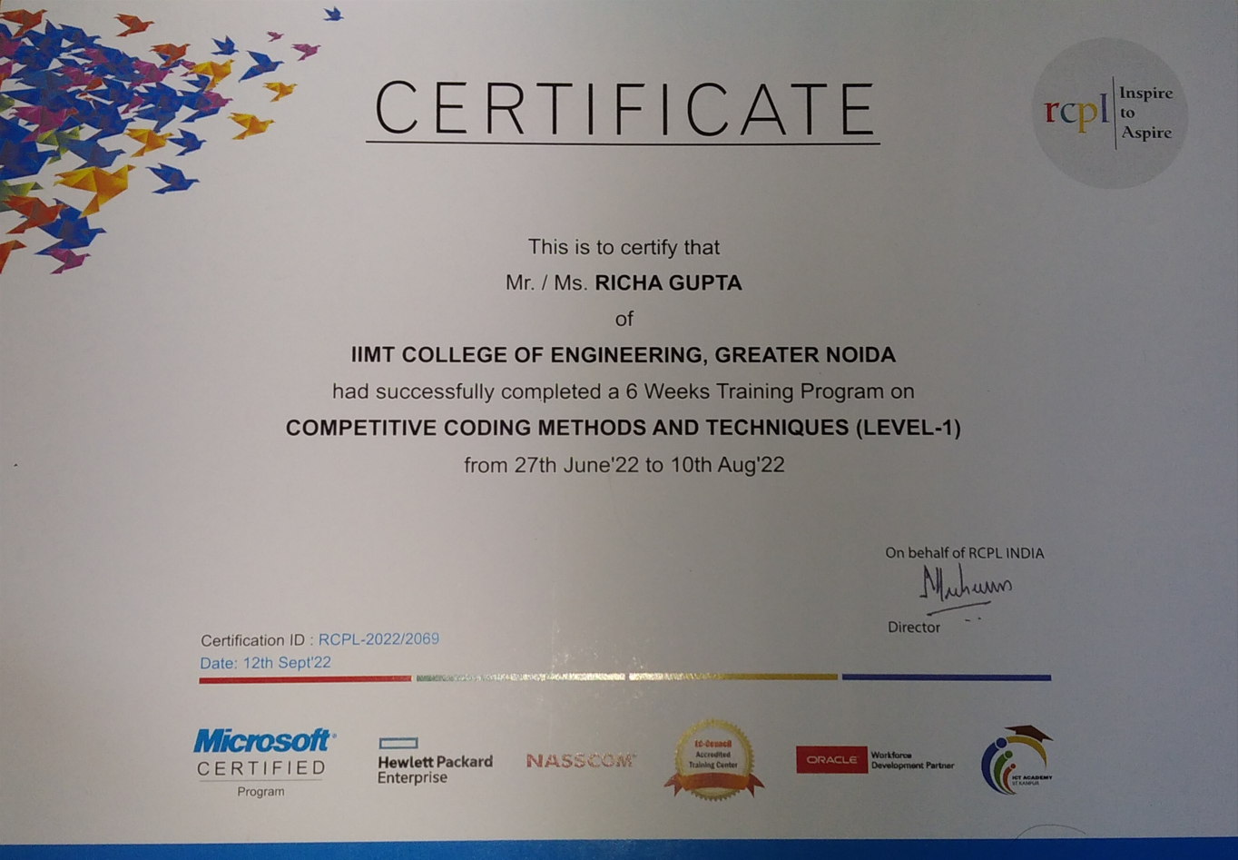



DECLARATION

We students of 7th semester hereby declare that this project entitled **“Store management system**” has been carried out by us in the Department of Information Technology of IIMT College of Engineering under the guidance of  **Vandana Jha.**

**Name Signature**

Richa Gupta ………………………………

**Place**  **Date:**

IIMT College of Engineering,

Greater Noida. ……………………………….



ACKNOWLEDGEMENT

We would like to acknowledge and express my deepest gratitude to **Vandana Jha** for the valuable guidance, sympathy and co-operation for providing necessary facilities and sources during the entire period of this project.

I wish to convey my sincere gratitude to the Head of Department and all the faculties of IT Department who have enlightened me during our studies. The faculties and cooperation received from the technical staff of Department of IT is thankful acknowledged.

1. Richa Gupta (Roll No. 1902160130039)

WEEKLY OVERVIEW OF TRAINING ACTIVITIES

1ST WEEK

INTRODUCTION OF PROGRAMMING LANGUAGE

2ND WEEK

INTRODUCTION OF C

3RD WEEK

DATA STRUCTURES

4TH WEEK

CORE JAVA

5TH WEEK

PYTHON

6TH WEEK

C++

STL

7TH WEEK

DBMS

MYSQL

8TH WEEK

PROJECT -STORE MANAGEMENT SYSTEM

INDEX

1. Introduction

1.1 Abstract

1. System Analysis

2.1 Software Requirement Specification (SRS)

2.2 Existing system

2.3 Software & hardware Requirements

2.4 Feasibility Study

1. System Specification

3.1 System Environment and Tools

1. System Design

4.1 Data Flow Diagrams

1. System Implementation

5.1 Screens and Reports

5.2 Database Description

1. System Testing
2. Scope of the Project
3. Conclusion
4. Bibliography

# INTRODUCTION

# 1. Introduction

Stores are required for the following purposes :-

1. Capital works
2. Operation and Maintenances Works
3. Other Commercial activities like hiring equipment etc..,

The ‘Stores Management System’ is targeted to automate the almost all of the processes mentioned above to reduce the clerical labor of the staff working in Stores both technical and as well as Accounts departments using the software Industry’s latest technologies and cost effective tools there by providing the better control to the management by avoiding manual errors etc..,

**1.1. Abstract**

**Project Title:** Stores Management System

The system creates a web based manufacturing system that enables a manufacturing industry to schedule its manufacturing operations based on the daily update of sales from its dealers. Once the sales figures of items for the past week are entered by the dealers over the internet along with the orders for the next delivery, the schedule for the next week’s production will be drawn up. A report of the required raw materials or parts will be drawn up with the product requirements over the internet & asked to quote their rates.

Once the rates are quoted, the order will be placed with the required delivery schedules. Once the parts the parts are supplied the stocks will be updated. Then a production plan will be drawn up taking the bill of materials into consideration. Once the production plan is approved, the stock will be updated when the material is issued. Once the finished products are available the delivery schedules will be drawn up based on the orders placed by the Dealers. The stocks with the dealers will also be maintained.

The Benefits of the Stores Management System is

* It is used as an intranet Application.
* Providing High-Security.
* Easy Business Solutions.

**SYSTEM ANALYSIS**

**2. System Analysis**

**2.1. Software Requirement Specification (SRS)**

**What is SRS**?

Software Requirement Specification (SRS) is the starting point of the software developing activity. As system grew more complex, it became evident that the goal of the entire system cannot be easily comprehended. Hence the need for the requirement phase arose. The software project us initiated by the client needs. The SRS is the means of translating the ideas of the minds of clients (the input) into a formal document (the output of the requirement phase.)

The SRS phase consists of two basic activities:

1. **Problem/Requirement Analysis:**

The process is order and more nebuious of the two, deals with understand the problem, the goal and constraints.

**2) Requirement Specification:**

Here, the focus is on specifying what has been found giving analysis such as representation, specification languages and tools, and checking the specifications are addressed during this activity.

The requirement phase terminates with the production of the validate SRS

document. Producing the SRS document is the basic goal of this phase.

**Role of SRS**

The purpose of the Software Requirement Specification is to reduce the communication gap between the clients and the developers. Software Requirement Specification is the medium through which the client and user needs are accurately specified. It forms the basis of software development. A good SRS should satisfy all the parties involved in the system.

**Purpose**

The purpose of this document is to describe all external requirements for mobile task manager. It also describes the interfaces for the system.

**2.2. Existing System**

The existing system for Stores Management System activities uses open source standard & technologies

The ‘Stores Management System package’ is targeted to automate the almost all of the processes mentioned above to reduce the clerical labour of the staff working in Stores both technical and as well as Accounts departments using the software Industry’s latest technologies and cost effective tools there by providing the better control to the management by avoiding manual errors etc..,

**2.3. Hardware And Software Requirements**

**2.3.1. Hardware requirements**

**SERVER:**

Processor : Pentium IV

Speed : 1.7 GHz

Memory Capacity : 1 GB

Hard Disk Capacity : 80 GB

Monitor Make : HP

**Client:**

Processor : Pentium IV

Speed : 1.7 GHz

Memory Capacity : 256 MB

Hard Disk Capacity : 20 GB

Monitor Make : HP

**2.3.2. Software Requirements**

Operating System : Windows 2000 Professional

Web Server : Apache Tomcat Web Server

Database : Postgresql

Enterprise Application : J2EE, JBOSS

Implementation Architecture : MVE,

3 Tier using Servlets, JSP

Scripting Languages : Java Script

Programming Language : Java

**SYSTEM SPECIFICATION**

**3. System Specification**

**3.1. System Environment and Tools**

JAVA

Creation Of Java

Java was conceived by James Gosling Patrick Naughton, Chris Wrath, Ed Frank and Mike Sheridan at SUN Micro Systems Incorporation in 1991. It took 18 months to develop the first working version. This language was initially called “oak”, but was renamed “java” in 1995, many more contributed to the design and evolution of the language.

Java Overview:

Java is powerful but lean Object-Oriented programming language. It has generated a lot of excitement because it makes it possible to program for Internet by creating applets, programs that can be embedded in the web page.

The context of an applet is limited by only one’s imagination. For Example, an applet can be an imagination with sound, an interactive game or a ticker tape with constantly updated stock prices. Applets can be just like decorations to liven up the WebPages, or they can be serious applications like word processors or spreadsheet.

But java is more than programming languages for writing applets. It is being used more and more for writing standalone applications as well. It is becoming so popular that many people believe it will become standard language for both general purpose and Internet Programming.

There are many buzzwords associated with java, but because of its spectacular growth in popularity, a new buzzword has appeared ubiquitous. Indeed, all indications are that it will soon be everywhere.

Java builds on the strength of C++. It has taken the best features of C++ and discarded the more problematic and error prone parts. To this lean core, it has added garbage collection (automatic memory management), multi threading (the capacity for one program to do more than one thing at a time) and Security capabilities. The results are that java is simple, elegant, powerful and easy to use.

**Introduction To HTML:**

The Hypertext Mark Up Languages (HTML) is simple markup language. Used to create hypertext documents that are portable from one platform to another HTML documents are SGML documents with generic semantics that are appropriate for representing information from a wide range of applications. This specification defines HTML version 3.2. HTML 3.2 aims to capture recommended practice as early ’96 and as such replacement for HTML 2.0(RFC 1866).

A set of instruction embedded in a document is called Markup Language. These instructions describe what the document text means and how it should look like in a display. Hyper Text Mark Up Language (HTML) is the language used to encode World Wide Web documents. It is a document layout and hyperlink specification language that defines the syntax and placement of special embedded directions that aren’t displayed by a web browser, but tells it how to display the contents of the documents including text, images and other supported media.

**Why to use HTML:**

Web site is a collection of pages, publications, and documents that reside on web server. While these pages, publications and documents are formatted in any single format,you should use HTML for home page and all primary pages of the site. This will enable the millions of users to easily access and to take advantage of your web site.

HTML is considered first for formatting any new material you plan to publish on the web. HTML documents are platform independent, meaning that they don’t conform to any standard .If they are created properly you can move home page to any server platform or you can access them with any complaint www browser.

**Block of HTML:**

HTML elements perform a defined task. HTML uses two types of elements.

Empty tags

Container tags

Empty (or open) tags and container tags differ because of what they represent formatting constricts such as line breaks and horizontal rules.

Container tags define a section of text and specify the formatting the container dot all of the selected text. A container tag has both a beginning and an ending.

**SYSTEM DESIGN**

**4. System Design:**

**4.1. Data Flow Diagrams:**

The data flow diagrams from the important modeling tools in the structure system analysis methodologies. The data flow diagrams are on of the most important tools used by system analyst.

Data flow diagram should be the first tool used by the system analyst to model system components. There are three kinds of system components.

1. Process
2. Entity
3. Data flow

**CONTEXT LEVEL**

SUPPLIER

SUPPLIER

**Action To Action**

**Perform Result**

SUPPLIER

SUPPLIER

**Receipt Receipt**

**LEVEL 02**

SUPPLIER

SUPPLIER

Item list Price

SUPPLIER

RECEIPT

Issues Module

Supplier

Provides

Receipt

Receives

Pass

Approve

User

Issue

Item

**SYSTEM IMPLEMENTATION**

**5. System Implementation**

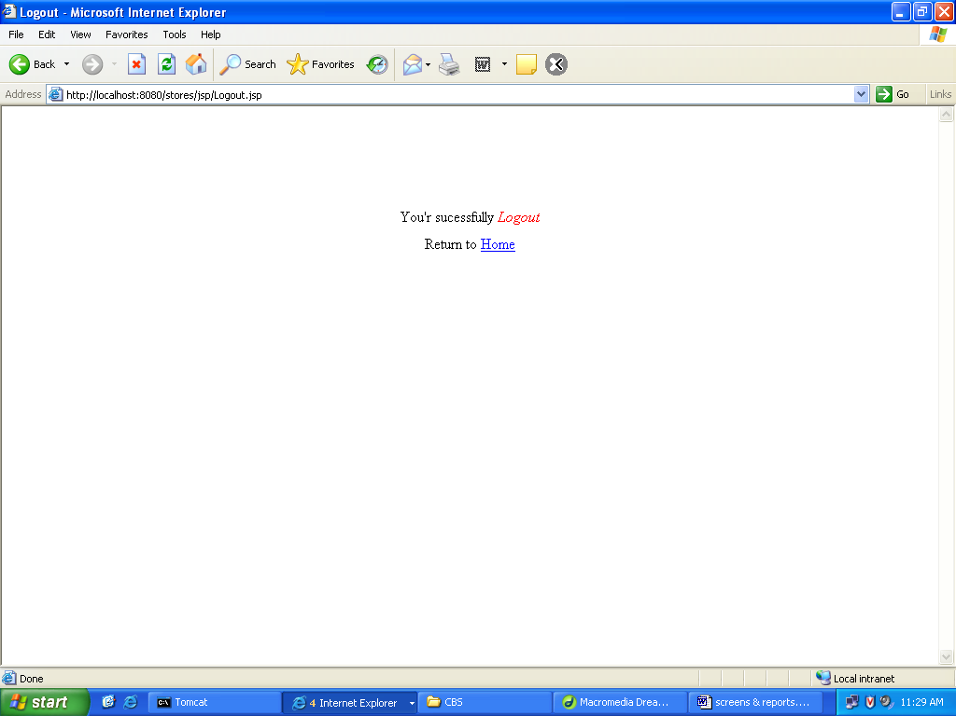

**5.2. Database Description:**

## User

|  |  |  |
| --- | --- | --- |
| **Field** | **Data type** | **Constraint** |
| Userid | Varchar2 (50) | Primary key |
| Password | Varchar2 (50) |  |
| Fname | Varchar2 (50) |  |
| Lname | Varchar2 (50) |  |
| Initials | Varchar2 (50) |  |
| Designation | Varchar2 (20) |  |
| Job | Varchar2 (20) |  |
| Store_code | Number (10) | Foreign key |
| Timestamp | Varchar2 (100) |  |
| Macaddress | Varchar2 (100) |  |

## Designation

|  |  |  |
| --- | --- | --- |
| **Field** | **Data type** | **Constraint** |
| Designation | Number (10) | Primary key |
| Short_name | Varchar2(20) |  |
| Full_name | Varchar2(50) |  |

## Organization

|  |  |  |
| --- | --- | --- |
| **Field** | **Data type** | **Constraint** |
| Organisationid | Varchar2 (10) | Primary key |
| Org_short_name | Varchar2 (50) |  |
| Org_full_name | Varchar2 (200) |  |
| Address | Varchar2 (100) |  |
| Street | Varchar2 (100) |  |
| City | Varchar2 (100) |  |
| Phone | Varchar2 (50) |  |
| url | Varchar2 (50) |  |

## Log table

|  |  |  |
| --- | --- | --- |
| **Field** | **Data type** | **Constraint** |
| Userid | Varchar2(50) | Foreign key |
| Appname | Varchar2(50) |  |
| Operation | Varchar2(100) |  |
| Date | Date |  |

## Issues

|  |  |  |
| --- | --- | --- |
| **Field** | **Data type** | **Constraint** |
| Sib_slno | Varchar2 (20) | Primary key |
| Sib_number | Varchar2 (20) |  |
| Date | Date |  |
| Receiving_section | Number (10) |  |
| Receivers_name | Varchar2 (150) |  |
| Receivers_designation | Varchar2 (50) |  |
| Tda | Varchar2 (20) |  |
| Work_order_number | Varchar2(100) |  |
| Remarks | Varchar2 (100) |  |
| Store_id | Varchar2(20) |  |
| Userid | Varchar2(50) | Foreign key |
| Timestamp | Timestamp |  |
| Macadderess | Varchar2(50) |  |
| Reqno | Varchar2(100) |  |
| Reqdate | Date |  |
| Work_order_date | Date |  |

**SYSTEM TESTING**

**6. System Testing:**

The development of Software system involves a series of production activities. There is a chance of errors to occur at any stage. Because of human inability to perform and communicate with perfection, a Quality Assurance Activity accompanies software development.

Software testing is a critical element of software quality assurance and represents the ultimate review of specification, design and code generation.

The increasing visibility of software as a system element and the costs associated with software failure are motivating forces for well planned, thorough testing.

For testing the system we followed the strategies given below.

**Testing Techniques:**

Different types of testing are

* Boundary Condition Testing
* Integration Testing
* Black Box Testing
* Validation Testing
* User Acceptance Testing

During the implementation for the system each module of the system is tested separately to uncover errors within its boundaries. User interface is used as a guide in this process. The validations have been done for all the inputs using Java Script.

For example to check whether the work allotted among the database correctly without exceeding the schemes which are not validated thoroughly and the internal database has to check the reflections in the database.

**Test Case Report:**

Here we specify all the test cases that are used for system testing. The different conditions that need to be tested along with the test case used for testing those conditions and the expected outputs are given. The goal is to test the different functional requirements. Test cases have been selected for both valid and invalid inputs.

|  |  |  |  |
| --- | --- | --- | --- |
| **S.No** | **Test case** | **Condition** | **Expected Output** |
| 1 | Get Systems | Input Domain name | Print list of all system in current domains & response time |
| 2 | Get User | Input Domain name | System id, user id, port no, domain name |
| 3 | Get Processes details | Select process | Output the details of processes |
| 4 | Get modules details | Select process & select thread opt | Details of modules |
| 5 | Get thread details | Select process & select thread opt | Details of threads |
| 6 | Stop the processes | System id, user id, password | Process close |
| 7 | Stop the system | System id | System close |

**SCOPE OF THE PROJECT**

**7. Scope Of The Project:**

**Stores Management System :**

The proposed system is ‘Stores Management System ’. This system is GUI based system and is user friendly. Stores Management System is accessible through the internet. Stores are required for the following purposes.

1. Capital works
2. Operation and Maintenances Works
3. Other Commercial activities like hiring equipment etc..,

The ‘Stores Management System package’ is targeted to automate the almost all of the processes mentioned above to reduce the clerical labour of the staff working in Stores both technical and as well as Accounts departments using the software industry’s latest technologies and cost effective tools there by providing the better control to the management by avoiding manual errors etc..,

**CONCLUSION**

**8. Conclusion:**

We have been given the problem of automating the material of stores in **APCPDCL**

**(Andhra Pradesh Central Power Distribution Company Limited)** at **APTRANSCO**. Earlier the materials of stores have only been automated. In our project **“STORES MANAGEMENT SYSTEM ”** we have automated the stores of the central power distribution company limited.

In Issues module, we have tracked the information regarding the issues of the receipts for the material that have been stored in the stores of the central power distribution company limited at **CPDCL**. This information can be easily made available to all the stores throughout the AP through intranet/ Internet.

As a result of this automation, manual workload is reduced and data retrieval becomes easy. This project can be helpful for centralization of information regarding the stores of **APCPDCL** at **APTRANSCO**.

**BIBLIOGRAPHY**

**9. Bibliography**

1. Database Management System

-C.J.Data

2.JAVA2 The complete Reference

-Patrick Naughton

3. Pure Java Script

-R.Allen Wyke & Charlton Ting

1. Hyper Text Markup Language
2. java.sun.com/products/**jsp/**
3. [**www.javascript.**com](http://www.javascript.com)
4. Jakarta.**apache.**org/**tomcat**
5. java.sun.com/**j2ee**
6. www.w3schools.com